ESTIMATION OF BUSINESS ESTIMATION

INTRODUCTION
A Business estimate is a document detailing how you plan on charging a customer for a good or service. It breaks down costs line by line (e.g., each cost for providing drywall installation) so customers know where the total is coming from.
This involves estimating all the expenses required to start and operate the business, such as equipment, rent, inventory, and marketing. By calculating these costs upfront, business owners can better plan their budget and avoid unexpected expenses. So the basic concept of estimating is to break down a project (building, road, bridge) into industry-standard trade packages. When you consider there may be between 50 to 100 trades on most building projects and then each trade may have hundreds or thousands of components.

OBJECTIVE
1.1.1 Objectives:

Cost Estimation
- To introduce the fundamentals of software costing and pricing.
- To describe three metrics for software productivity assessment.
- To predict the quantity, cost, and price of the resources required to complete a job within the project scope.
- Estimation in civil engineering is the process of determining the number of materials, resources, and especially project costs needs to operate during a construction project.

1.1.2 Methodology:

Business valuation: A general process of determining the economic value of a whole business or company unit.

Accounting Valuation: The process of valuing a company assets and liabilities the purposes of financial reporting.

Valuation Analysis: A process to estimate the value or worth of an asset.

2. PROBLEM DEFINITION & DESIGN THINKING
2.1 Empathy Map
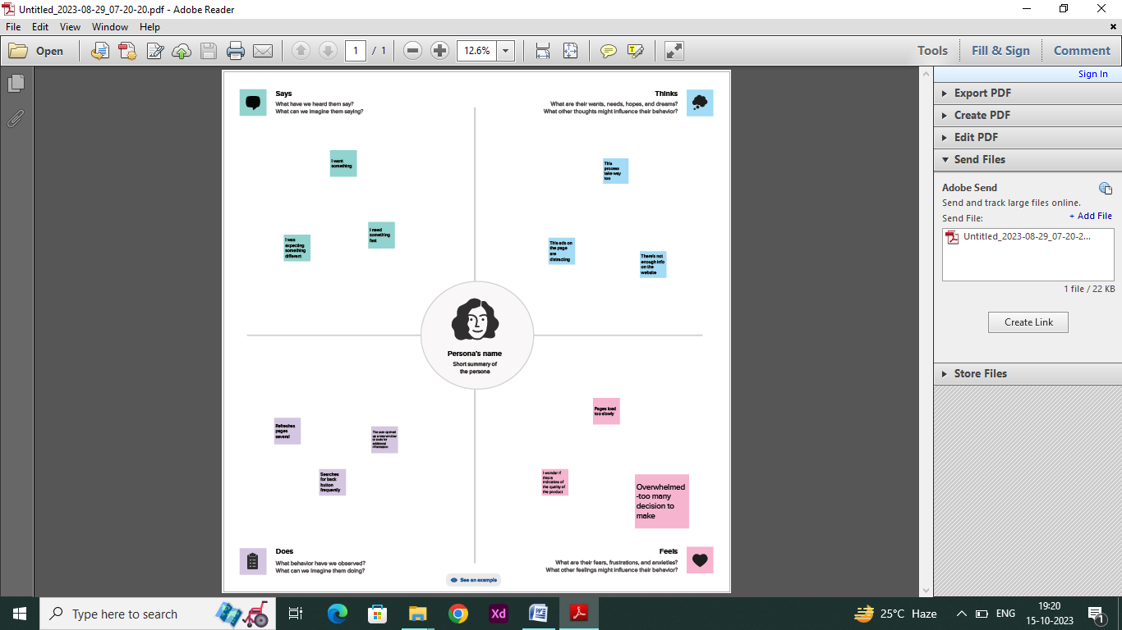
2.2 Ideation & Brainstorming Map
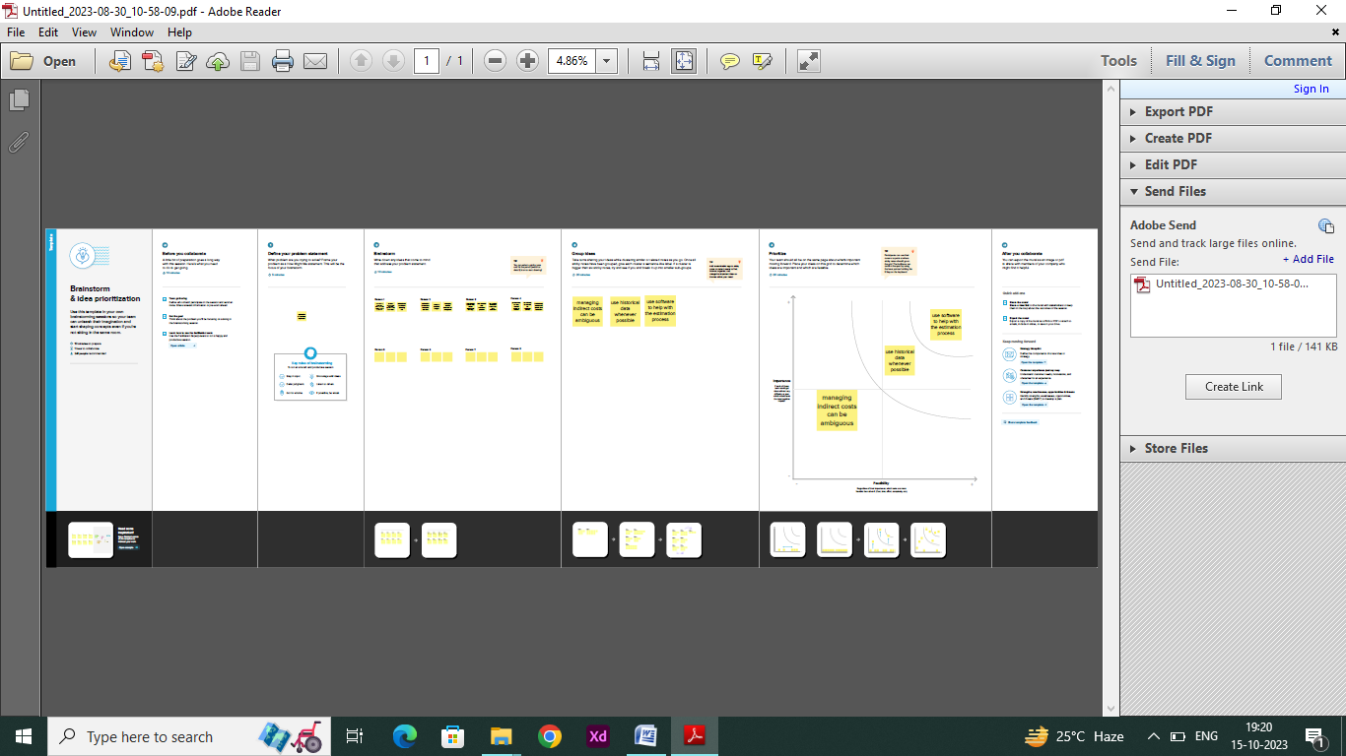
3. RESULT
Data visualization involves the creation of visual representations of data with the aim of facilitating the comprehension and exploration of information. The primary objective is to enhance the accessibility, intuitiveness, and interpretability of intricate datasets. Leveraging visual elements like charts, graphs, and maps, data visualizations serve as powerful tools to expedite the identification of patterns, trends, and outliers within the data, enabling individuals to swiftly discern insights embedded in the information.
3.1 Visualizations
A given dataset possesses the potential for a diverse array of distinctive visual representations. Various common visualization types, such as bar charts, line charts, heat maps, scatter plots, pie charts, maps, among others, are valuable tools for scrutinizing the performance and efficiency of a project. These visual tools serve multiple purposes, including performance comparison, temporal change tracking, and illustrating the distribution and relationships between different variables within the dataset.
KPI

Estimation
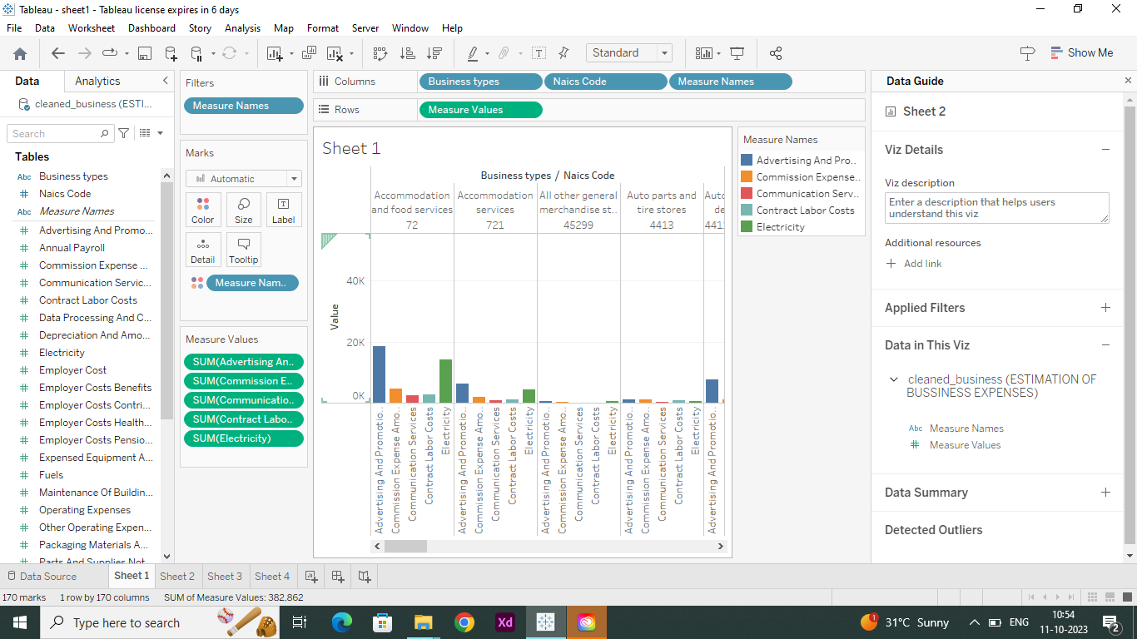

Business Expenses
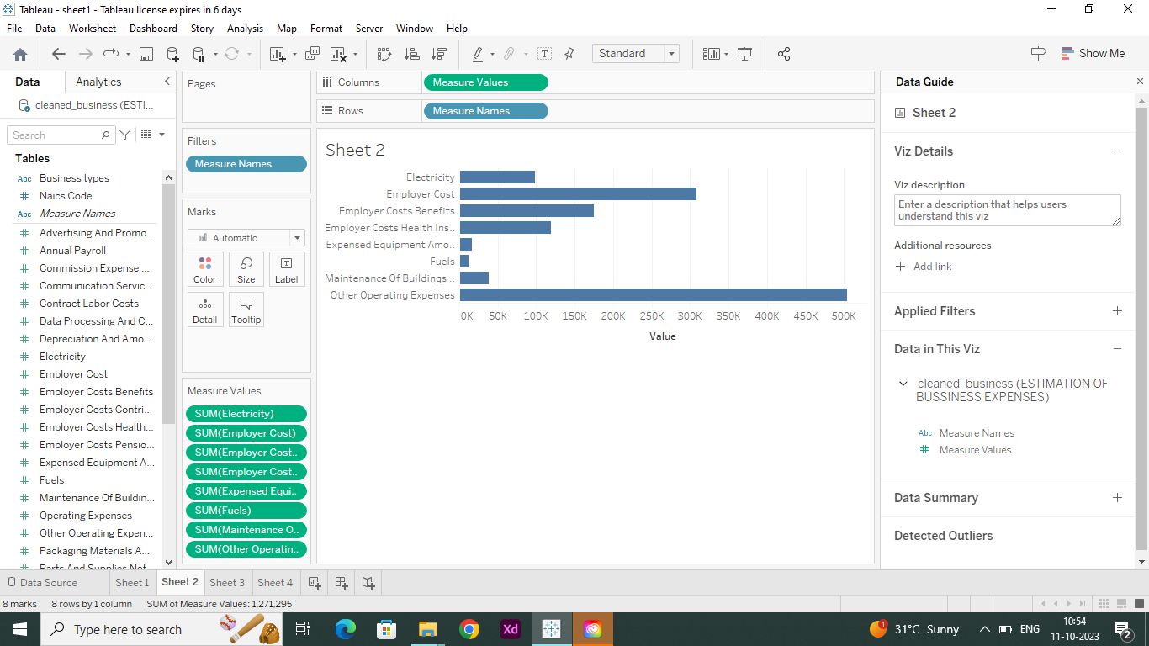
Estimate a expenses
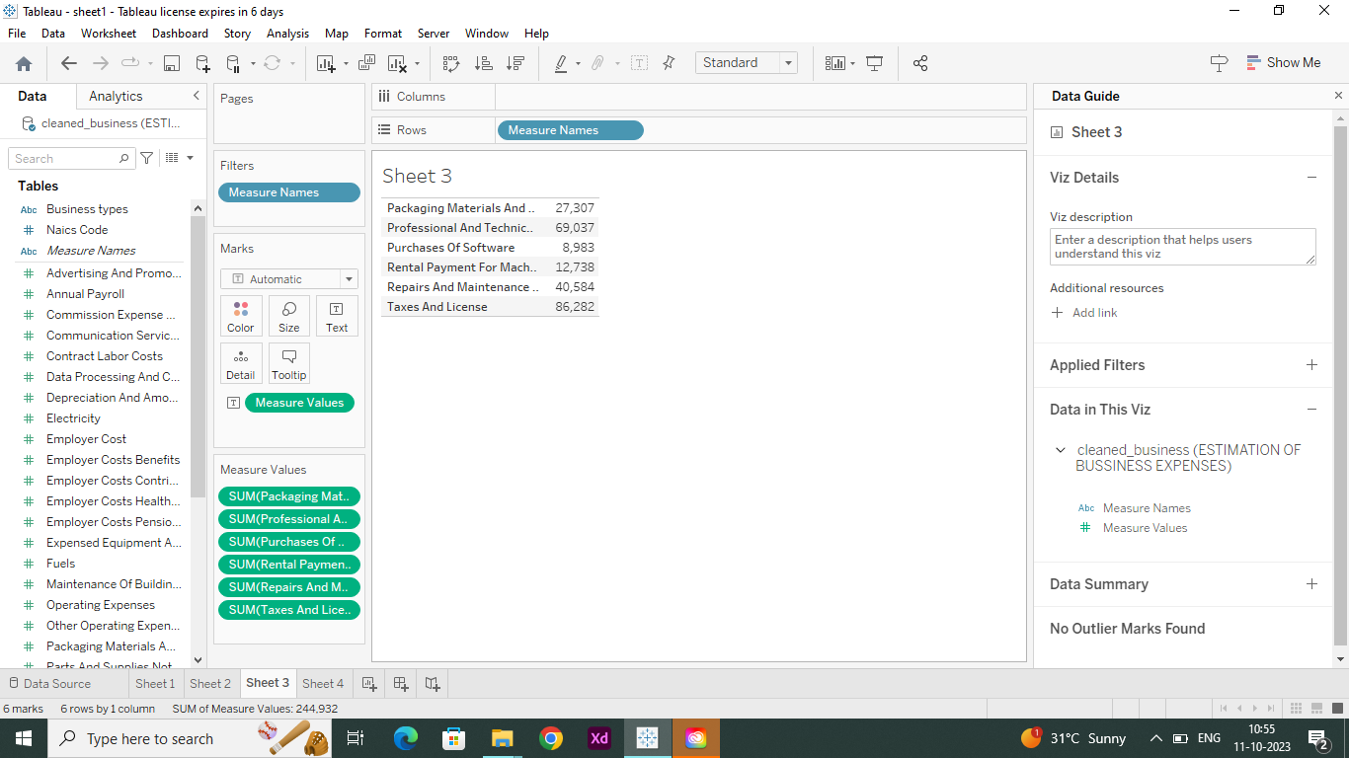
Estimate a Business
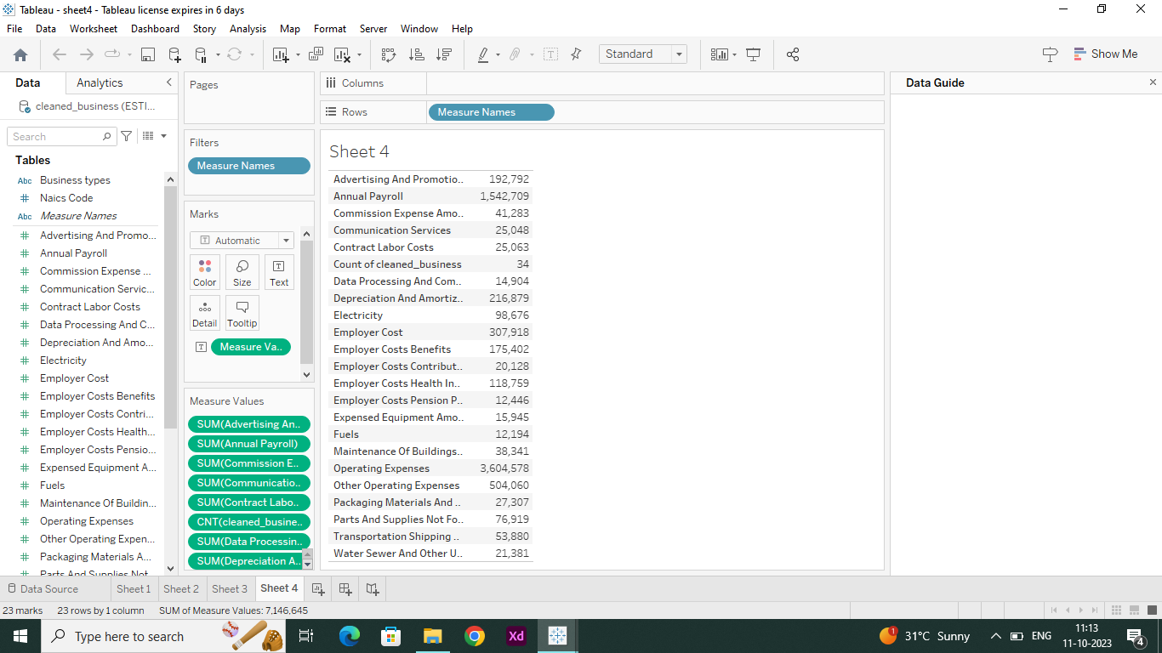

3.2 Dashboard

Dashboard 1
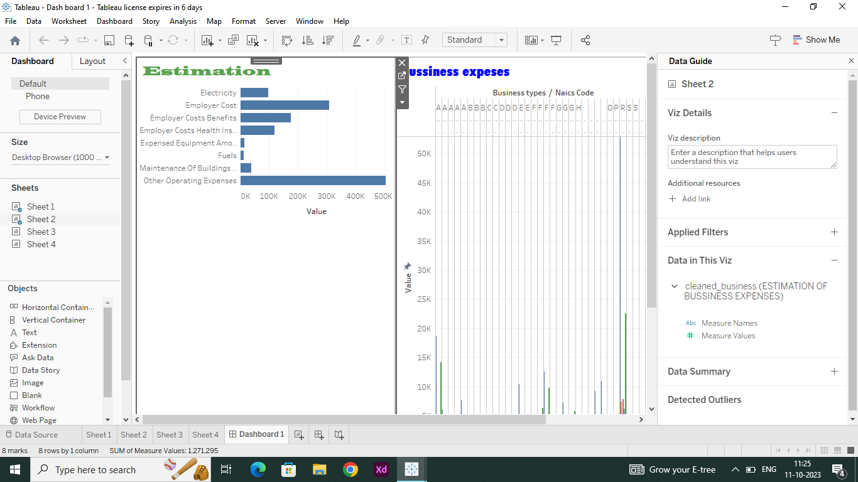
Dashboard 2
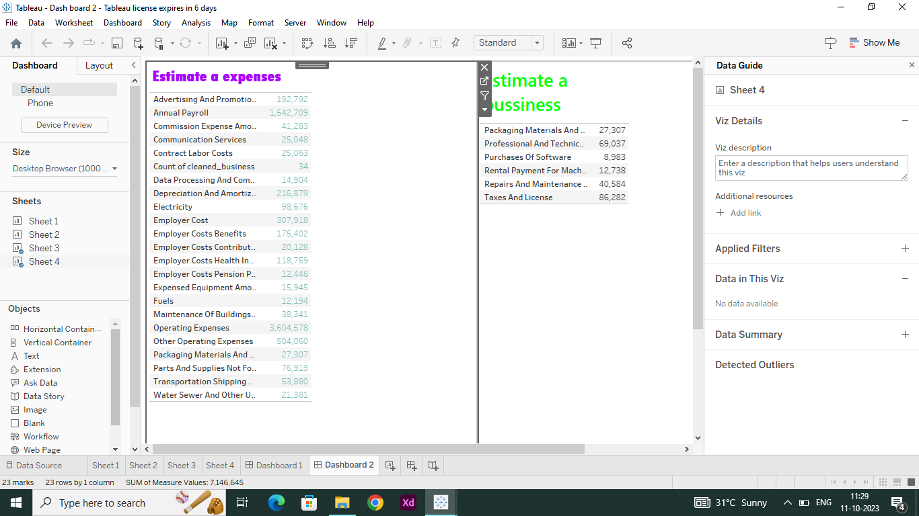

3.3 Story

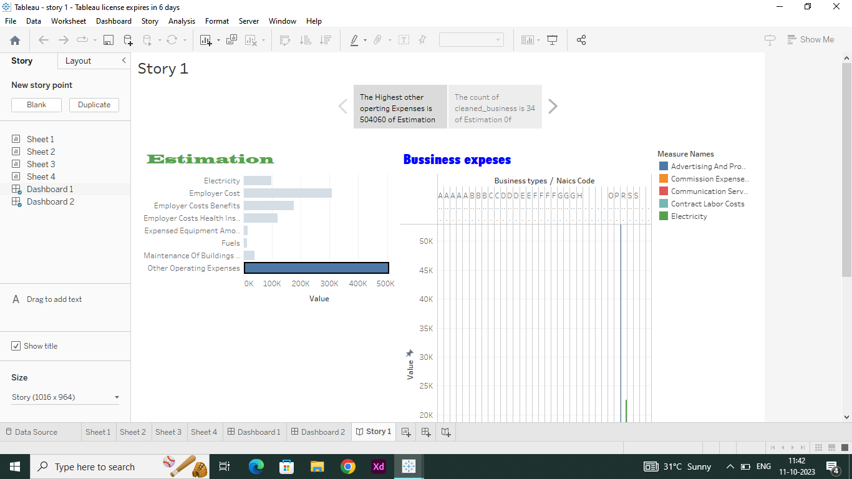
3.4Performance Testing
- Amount of Data Rendered to Tableau:
The volume of data presented in Tableau is directly influenced by the dimensions of the dataset.
- Utilization of Data Filters:

4. ADVANTAGES & DISADVANTAGES
4.1 Advantages

- Maintenance of financial records of business.
- Establishment of financial statements.
- Decision building.
- Correlation of results.
- Evidence in legal concerns.
4.2 Disadvantages
- Expenses information related to Accounting in terms of money.
- The accounting report is based on estimates.
- Accounting reports may be biased.
- Registration of fixed assets at the original cost.
- Manipulation of statements of accounts.
- Money as a determination unit changes in value.

5. APPLICATIONS

Cost estimation : Communicate a realistic view of the likely cost outcome, which can form the basis of the plan for executing the work.
Cost accounting : companies identify areas where they ay be able to better control their costs, and also informs pricing decisions to ensure profitability.

6. CONCLUSION
The ESTIMATION OF BUSINESS EXPENSES project , is a estimate of the value of a business, business ownership interest, security, or intangible asset, arrived at by applying the valuation procedures appropriate for valuation engagement.
7. FUTURE SCOPE
In 2023 alone, around 19000 startup businesses started in India. This shows the bright scope for new business ideas and ventures. So, if you are thinking about starting your own future business in India; then its high time.

